**ASSIGNMENT # 04**

**OBSERVER PATTERN** **MAJID HUSSAIN(0062)**

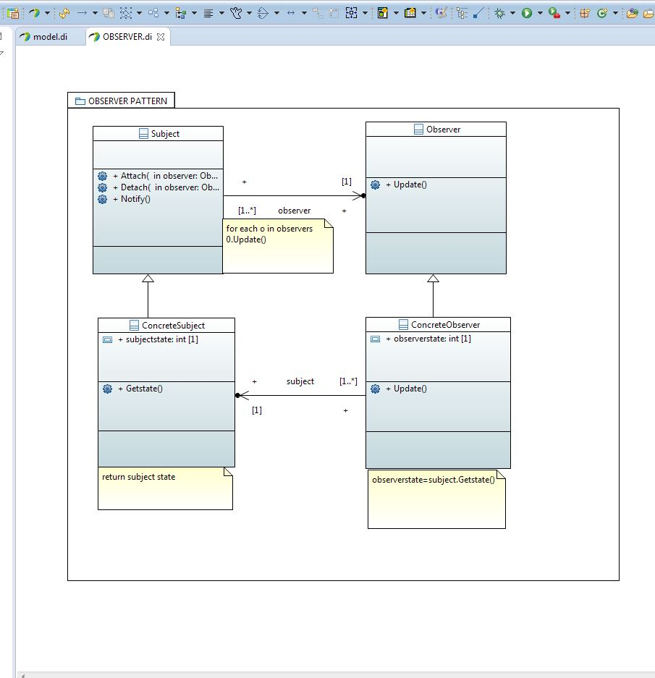

Applications of Observer pattern:

The observer pattern is used when:

•The change of a state in one object must be reflected in another object without keeping the objects tight coupled.

•The framework we are writing needs to be enhanced in future with new observers with minimal changes.

**Some Classical Examples:**

**Model View Controller Pattern** - The observer pattern is used in the model view controller (MVC) architectural pattern. In MVC the pattern is used to decouple the model from the view. View represents the Observer and the model is the Observable object.

**Event management** - This is one of the domains where the Observer pattern is extensively used. Swing and .Net are extensively using the Observer pattern for implementing the events mechanism.

**Websites:**

When you subscribe to any website. You are on observer in this case who has subscribed to a website (Subject) for getting notified about its post.

**Software Repository:** Under the push notification model, devices are observable for the central software repository & as soon as there is new software from one of the observers, all the devices registered will be sent a push notification to check for that software.

UML Design in this phase:

In our project, we have a spreadsheet which should be observed by the different views. When the state of the spreadsheet is changed, all the views are updated. So, the observer pattern is quit suitable for this purpose. Based on this pattern, I design the first class diagram in UML, which is shown in the following diagram.

